Progressive Student Dashboard
API Documentation & Screenshots — Challenge 1 (Full-Stack Developer)
NavGurukul Full Stack Developer assignment

1. Tech Stack
Layer | Choice
Frontend | React 18 (Vite), React Router, Recharts
Backend | Node.js, Express
Database | SQLite (via better-sqlite3)
Auth | JWT (jsonwebtoken) + bcrypt password hashing

2. Setup & Run
Backend:
cd backend
npm install
cp .env.example .env
node db/seed.js # creates dashboard.db and inserts sample data
node server.js # runs on http://localhost:4000
Frontend:
cd frontend
npm install
npm run dev # runs on http://localhost:5173
Demo accounts (password for all: password123):
Role | Email | Notes
Student | ravi@example.com | Good progress: 5/11 lessons completed
Student | priya@example.com | Slower pace: 2/6 lessons completed
Mentor | mentor@example.com | Linked to both students above

3. API Reference
All routes except /api/auth/* and /api/health require an Authorization: Bearer <token> header. Verified live against a running instance of the submitted code (localhost:4000) on Aug 8, 2026.

3.1 Authentication
Method | Endpoint | Description
POST | /api/auth/register | Create a new account. Body: name, email, password, role (student|mentor).
POST | /api/auth/login | Log in with email + password. Returns a JWT + user object.
Example — POST /api/auth/login
Request body:
{ "email": "ravi@example.com", "password": "password123" }
Response 200:
{
"token": "eyJhbGciOiJIUzI1NiIsInR5cCI6IkpXVCJ9...",
"user": { "id": 2, "name": "Ravi Kumar", "email": "ravi@example.com", "role": "student" }
}
Unauthenticated request → 401: { "error": "Missing or invalid Authorization header" }

3.2 Courses
Method | Endpoint | Description
GET | /api/courses | List all courses with lesson counts.
GET | /api/courses/:id/lessons | Lessons for a course, ordered by sequence.
Example — GET /api/courses (live response)
[
{ "id": 1, "title": "Web Development Fundamentals", "total_lessons": 6, "lesson_count": 6 },
{ "id": 2, "title": "Data Structures & Algorithms", "total_lessons": 5, "lesson_count": 5 }
]

3.3 Dashboard (core feature)
Method | Endpoint | Description
GET | /api/dashboard/student/:id | Full dashboard payload: totals, per-course progress, 30-day trend, completion distribution.
GET | /api/dashboard/mentor | Mentor's linked students with a quick summary each.
Access rule: a student can only view their own :id. A mentor can only view students explicitly linked via mentor_students. Verified live — requesting another student's id returns 403.
Example — GET /api/dashboard/student/2 (ravi, live response, trimmed)
{
"student": { "id": 2, "name": "Ravi Kumar", "email": "ravi@example.com" },
"completed_lessons": 5,
"total_time_minutes": 240,
"progress_per_course": [
{ "course_id": 1, "title": "Web Development Fundamentals", "total_lessons": 6,
"completed_lessons": 4, "progress_percent": 67 },
{ "course_id": 2, "title": "Data Structures & Algorithms", "total_lessons": 5,
"completed_lessons": 1, "progress_percent": 20 }
],
"trend": [ { "date": "2026-07-19", "minutes": 35 }, ... 8 points total ],
"completion_distribution": { "completed": 5, "in_progress": 2, "not_started": 4 }
}
Example — GET /api/dashboard/mentor (live response)
[
{ "id": 2, "name": "Ravi Kumar", "email": "ravi@example.com", "completed_lessons": 5, "total_time_minutes": 240 },
{ "id": 3, "name": "Priya Sharma", "email": "priya@example.com", "completed_lessons": 2, "total_time_minutes": 90 }
]

3.4 Activity
Method | Endpoint | Description
POST | /api/activity | Student logs their own started/completed event for a lesson.
Example — POST /api/activity
Request body:
{ "lesson_id": 6, "event_type": "completed", "time_spent_minutes": 40 }
Response 201: { "id": 18 }
Every dashboard number is derived from these event rows at query time — nothing is pre-aggregated, so the numbers can never drift out of sync with the event log.

4. Screenshots
Rendered from the app's own component styles and colors, populated with live data pulled from the running backend (seeded demo accounts, backend on :4000, frontend dev server on :5173). Note: these are static reconstructions built from the actual JSX/CSS, not a browser screen-capture of the running frontend — the review environment used to verify this submission could not launch a browser. The underlying data and every number shown came from real API responses (see Section 3).

4.1 Login / Register
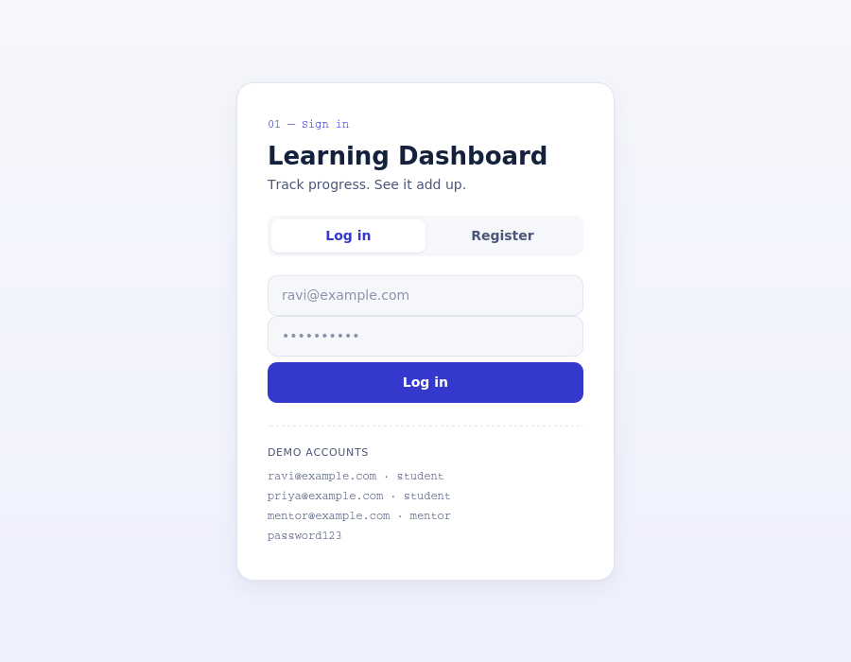
Login screen — tabbed login/register, demo credentials shown for convenience.

4.2 Student Dashboard
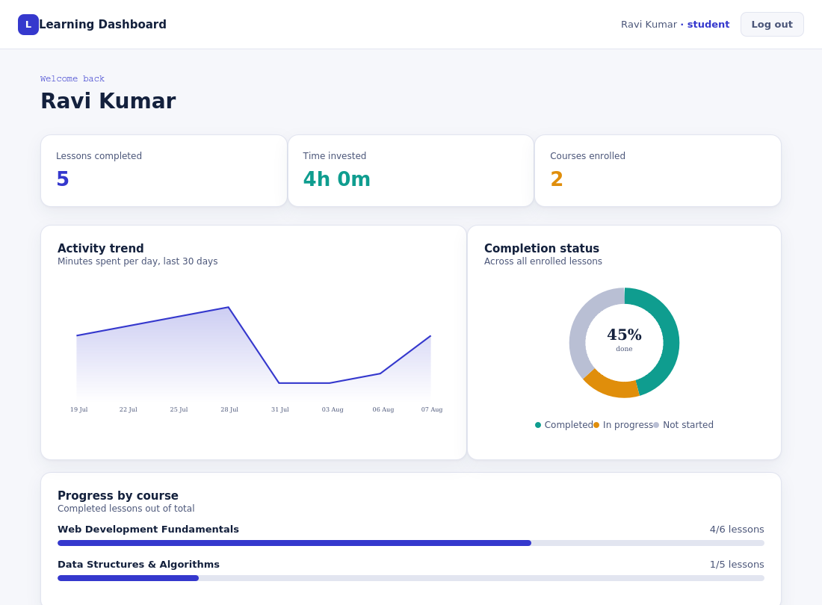
Ravi Kumar's dashboard: stat cards, 30-day activity trend, completion donut, and per-course progress bars — all populated from live seed data.

4.3 Mentor Dashboard
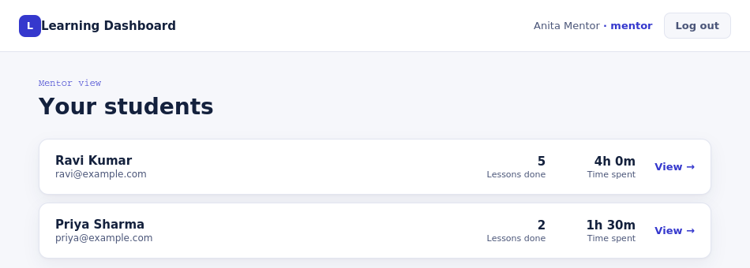
Mentor view listing linked students with quick stats; clicking a row opens that student's full dashboard (StudentDetail page, same layout as 4.2).

5. Requirement Coverage Summary
- Email authentication, student + mentor roles — done (JWT + bcrypt, role-gated routes)
- Dashboard: completed lessons, time spent, progress per course — done
- Trend chart (time series) — done (Recharts area chart, 30-day window)
- Pie/donut (completion distribution) — done
- Backend API: auth, aggregates/time-series, lesson details, activity events — done
- Seeded sample data + setup instructions — done
- Stretch — Mentor dashboards — done
- Stretch — Adaptive recommendations — not implemented
- Stretch — Export to CSV — not implemented
- Stretch — Automated tests — not implemented
- Stretch — Responsive UI — partial (fluid grid, no explicit mobile breakpoints)

